|  |
| --- |
| POWER SUPPLY & DATA LOGGING |
| Project for EMI, MSE 1 |
| A power supply is a device that supplies electrical energy to any electrical load. This power supply takes its input from the AC Mains and converts that into a fixed 5V and a variable voltage of up to 12V, both readily available to the user for the usage through the adapter jack ports. The process of saving the data generated by the power supply into an SD Card for future reference is called ‘Data Logging’. |
|  |

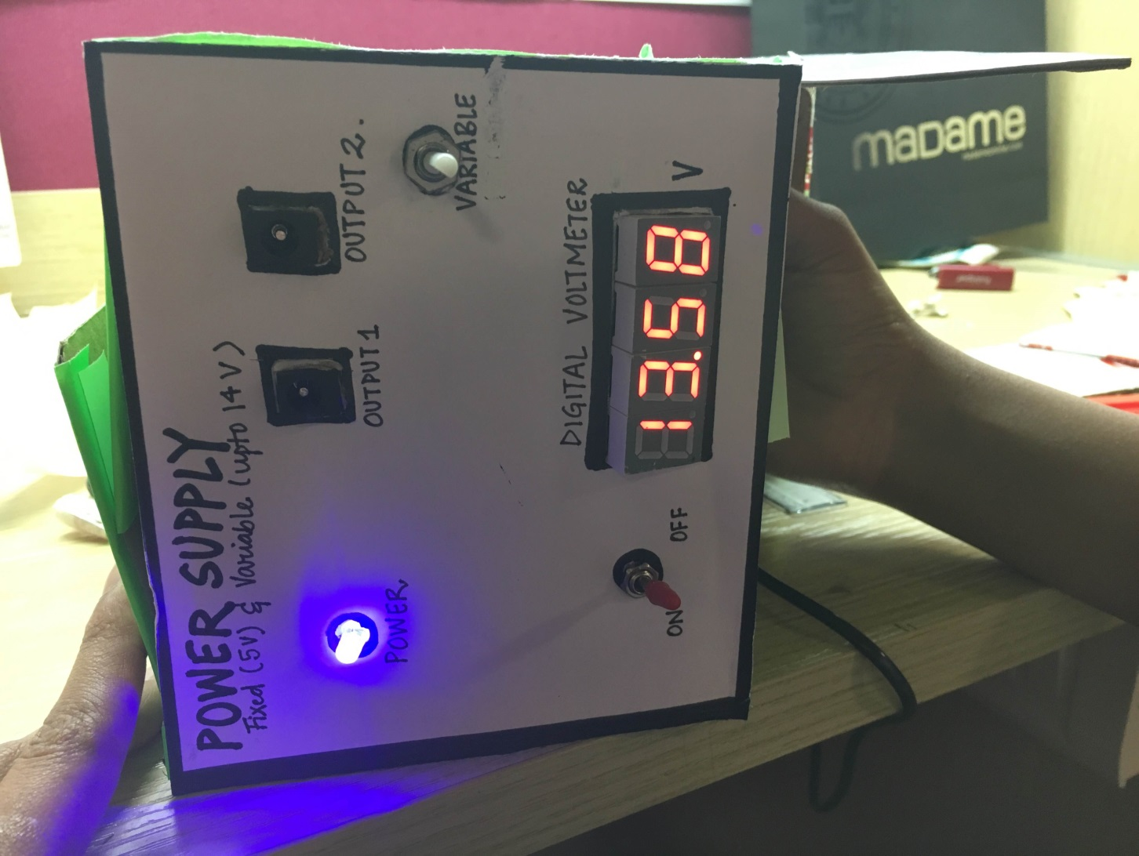

**MAKING OF A POWER SUPPLY**

1. **OBJECT**

A power supply with fixed (5V) as well as variable voltage output (up to 12 V) which allows subsequent data logging.

1. **SYSTEM FEATURES**

The experimental unit comprises of the following blocks or subsystems on the panel:

1. A main cable for connecting to the external mains source.
2. An adapter jack for fixed 5V supply.
3. Another adapter jack for variable output supply (for up to 14 V).
4. A potentiometer for varying the external variable output voltage.
5. A data logging unit based on Arduino and SD card adapter.
6. **BACKGROUND SUMMARY**

A power supply is a device that supplies electrical energy to any electrical load. Every power supply obtains the energy it supplies to the load as well as the energy it uses for performing the tasks from an external source (mostly from the mains). All power supplies have a power input, which receives energy from the energy source, and a power output that delivers energy to the load. There exist various types of power supplies: DC Power Supply, AC-to-DC Power Supply, Linear Regulators, Programmable Power Supply, Switched Mode Power Supply etc. Power supplies are a fundamental component of many electronic devices and therefore used in a diverse range of applications.

This project will deal with construction of a variable 1A power supply with the help of a few basic components thus, minimizing the cost and the surface area occupied. Thus, the project is cost effective, compact and comes with the perk of easy troubleshooting due extra simplified circuitry. Furthermore, being bound in a cardboard, it is extremely lightweight as compared to conventinal power supply.

The power supply designed in the project basically converts the 230V, 50 Hz mains supply into a fixed voltage of 5V and a variable voltage of up to 12 V. The outputs can be utilized by using the adapter jack port.

**4. WORKING**

The transformer used in the project is a central tapped 12 V step down transformer. The +12 V and the GND wire have been utilized for the rectifier of the ‘Variable Supply Unit’ whereas the -12V and the GND wire have been used for the ‘Fixed 5V Supply Unit’. A smoothing capacitor of 1000uF has been used to removes the AC ripples and filters the rectified signal. In case of the LM317, the signal is fed to pin number 3 directly and via a 240 ohm resistor and 10k potentiometer to the pin numbers 1 and 2. The voltage spo developed is displayed on a ‘Digital Voltmeter Panel’ and the output of the same is also interfaced with an adapter jack for output operations.

In case of the fixed voltage unit, the IC used is 7408 which is a fixed voltage regulator and transforms the voltage produced by the step down transformer to the fixed voltage of 5 volts. Furthermore, the output so produced is interfaced with an adapter jack for output operations purpose.

**5. CIRCUIT DAIGRAM**

5.a. Power Supply  
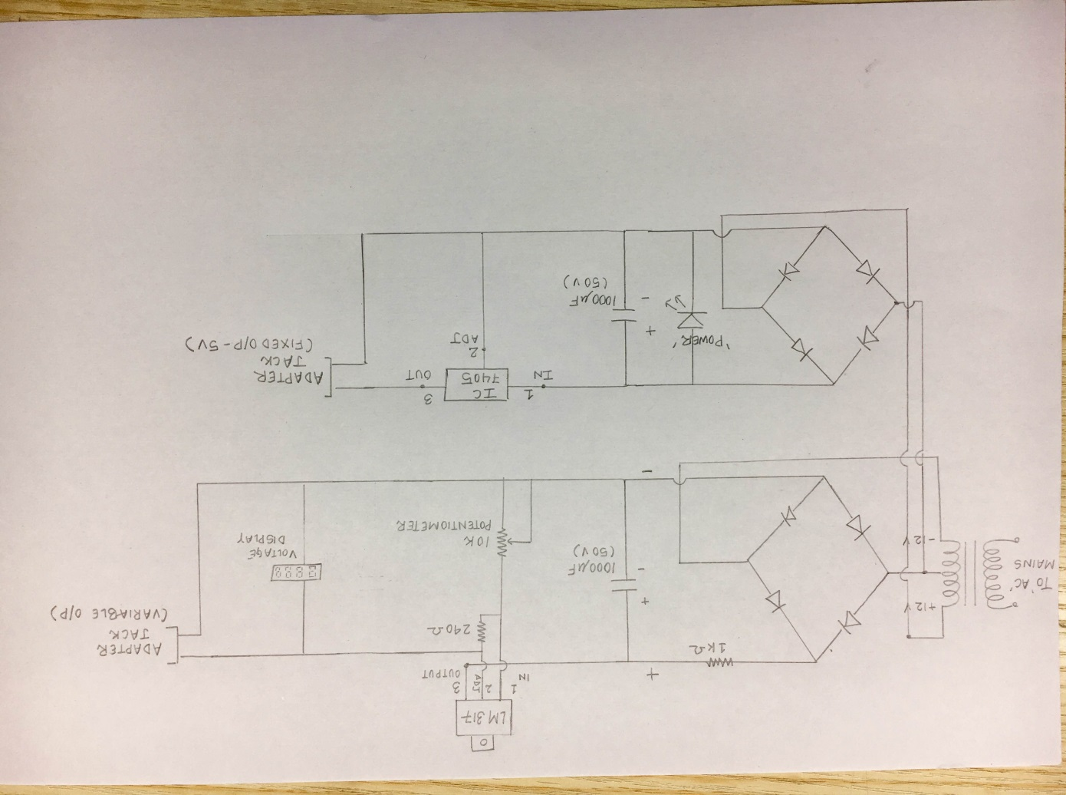

5.b. Data Logging Unit

**6. PROCEDURE**

1. Connect the power supply into the AC mains and notice the blue LED glowing which indicates supply of power.
2. Feed the output of the power supply into the input of the data logging unit.
3. Take the output across Adapter Jack 1 for a constant voltage of 5V. (This can be even used to power the data logger).
4. Take the output across Adapter Jack 2 for a variable voltage (up to 12 Volts).
5. Vary the potentiometer knob and observe the reading on the voltmeter display to set to the desire voltage.
6. If the data stored is to be viewed, the device can be powered from the laptop and Serial monitor can be monitored using the Arduino platform.
7. Once done with the work, please switch off the supply.

**7. POSSIBLE SORCES OF ERROR**

1. The transformer not being of a very high and refined quality can produce the variable voltage up to a range of 14 V. This happens due to poor accuracy in the number of windings in the primary and secondary of the transformer.
2. The digital voltmeter panel doesn’t have a very good calibration due to usage of not so robust quality of components. Thus, the voltage shown is the approximate voltage and not the precise voltage.
3. The components like the IC 7408 and LM317 have been locally manufactured and don’t totally obey the datasheet, at times.
4. At times, the calibration of the 7 segment display goes wrong due to the tampering of the calibration knob in any way. Thus, it should be adjusted again to fix the error.
5. The circuit being soldered onto a PCB, without any robust capsulation, can be prone to break of the wires from soldered area. Thus, checking of wires for proper soldering could be one way to troubleshoot.
6. The data logger sometimes fails to detect the presence of SD card, although inserted. This can be overcome by checking the internal connections as well as the insertion of the card in the adapter. A ‘click’ sound is heard upon proper insertion.
7. The connections should be right and tight for proper working of the model.